Contents
Introduction 1
Background Information 1
jhjkhj 1
Rationale 1
Problem Definition and scope limitation 1
Organization of the rest of the report 1

Introduction

Background Information

Rationale

Problem Definition and scope limitation

Organization of the rest of the report

- Background Research

Mobile Applications
The amount of smartphone users has increased dramatically since the production of them. Between 2011 and 2012 there was a 20.9% increase in the ownership of a smartphone, furthermore between 2014 and 2015 there was another increase of 9% . This is highly significant because it shows that smartphones are becoming more affordable to users and by owning a smartphone they are more likely to develop their habits of using mobile applications.
http://www.itproportal.com/2015/02/26/uk-smartphone-ownership-reaches-record-high-growth-continues-slow/

The UK has become a “smartphone society”. There are 38 million smartphone owners and regular users in the UK, not only are there many users who use their smartphones it has also been found that smart phones overtake laptops as the UKs number one device. It was also found that users spend twice as long on their smartphones compared to their laptops. Smartphones are easier to carry compared to laptops, they are also having access to the internet and with the rise of 4G it allows for a faster online access.
http://media.ofcom.org.uk/news/2015/cmr-uk-2015/

GPS Navigation
A GPS system involves a GPS receiver and an audio component, these types of systems are usually designed for the purpose of having it as a car-based equipment or smartphone apps. GPS stands for global positioning system; it uses satellite signals to find the receivers position on earth. This was first developed by the US, originally being used for military purposes. However, since the GPS was made available to consumer markets it has become widely used around the world and anyone is able to use a GPS if they have a GPS receiver. It is now also used in many mobile applications for example Google Maps.
Not only are users now able to see their position on Earth with latitude and longitude coordinates but since technology has developed over the years, there is now mapping of these locations and are able to use these maps to navigate around the current location. With the user of an audio component having a GPS navigation system has become extremely popular with the commercial markets. Uses are now able to get directions while simultaneously walking or driving while being hands free, making it more appealing to the users.

2.1 Existing Systems
Research comparison:
In this research comparison, three different applications will be compared. Both these applications possess features which would desirable to have in the development of this application; therefore they will be looked at in detail to gather requirements.
A research comparison is used in this case because it is a very easy and less time consuming technique. It will also show the strengths and weaknesses of both applications and allow us to pick which features are more desirable than others.
Another way to gather requirements would be to conduct interviews; however it was found that this would be less favourable. A disadvantage of using an interview is there isn’t enough time to gather data from a large sample therefore it would make the data gathered less reliable and may only represent a particular population.

HERE maps:
HERE maps are a mobile application which is owned by NOKIA. It is a mapping application which is available in over 100 countries (1). The main use of this application is to guide the user using turn by turn walking navigation. HERE maps have many different features which are appealing to the target audience.

Strengths:
This application contains many features which are not currently used in existing applications. One of them being the use of having offline maps. This is one of the requirements desired by users when using a navigating application. The benefits of having this are that it will allow users to download maps of certain areas and allow them to still use the application without having needed a network connection.
In terms of user friendliness it has very simple features which are easy to use. For example one of the features, route options is easily accessible and allows the user to also view estimated time travel alongside.
In terms of user interaction, there is an uncluttered interface. It has a very simple interface and also allows the user to customize the interface if they please.
Weaknesses:
Although it has a lot of strengths there are also some weaknesses in terms of functionality that we need to consider. One of the biggest weaknesses being that there is no voice guidance. Instead of having voice guidance it produces a beep sound whenever it is time to turn. This may cause confusion to the user not knowing whether to turn left or right. In comparison to GOOGLE maps, it is much more specific as it would say ‘Turn left at Turin Street’. This is a better functionality compared to HERE map.

Google Maps:
As one the most popular of navigation applications, Google maps is widely used across the globe. It is a web mapping application which is now used across all platforms. Developed by Google it offers different functionalities such as Street maps and route planning. When Google maps for mobile were introduced they developed a GPS turn by turn navigation which is now widely common across all other existing mapping applications. It is considered to be the most widely used app for smartphones with about 54% of users using it at least once. (2)
Strengths:
Being the most used navigation application, there are a lot of strengths that Google maps have, one being the degree of accuracy. Google maps provide layouts of roads, locations of cities and towns, places of interests such as restaurants and hotels. By the use of street view they are able to give further directions as the user will now be able to familiarise themselves with the location and easily gain directions if lost.
One other strength of this application is having different transportation methods; the user is able to select a type of transportation they would like to use to get to their desired destination. This feature also displays the time it would take to get to the location.
In terms of user interaction, the application is very easy to follow. The map displayed contains detailed information about a certain location, compared to HERE maps, Google maps give you more information in terms of street names and clearly highlights major streets.

Weaknesses:
However like all applications there are some weaknesses associated with this application. It does not have up to date information. For example there may be unusual conditions that may have occurred in a location, there may be roads which have been damaged and may not display remote locations.
Another weakness of this application is that it does not have offline maps. This is one of the biggest flaws that the application has. If the user does not have mobile data or an internet connection, they will not be able to use the application. There is not much support for offline maps however it is possible to download maps beforehand.

MapQuest:
MapQuest is an American mapping service owned by AOL. This is another popular application used for navigation.
Strengths:
Weaknesses:

Proposed System
Unique Features
Comparison

- Requirements and capture analysis
Functional Requirements

- Design

This section will talk about the design of the project; it will include the steps used to create the project and what different frameworks were used to carry out the project. It will also discuss the software methodology used and include architectural models of this project as well as the communication and data flow within the software.

Software Development Life Cycle

Software Development Life Cycle (SDLC) which is sometimes referred to as Software development process is a process used to design, develop and test software. There are various SDLC methodologies that can be used in the process of developing the software. Each process model has a series of steps unique to its type. For this section 2 software methodologies will be compared, the Waterfall Model and the Agile Model.

Waterfall Model

The waterfall model was the first model to be introduced, it contains steps which are easy to understand and each step must be completed before moving on to the next phase. This is because it has a linear sequential flow, the outcome of one phase acts as the input to the next phase. In a waterfall model the phases do not overlap.

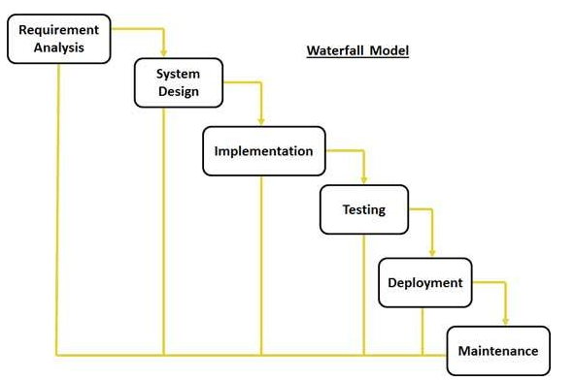

The following figure contains a visual representation of the waterfall model
http://www.tutorialspoint.com/sdlc/sdlc_waterfall_model.html

Advantages:

Some advantages of using the waterfall model include:

- Easy to use
- Phases are completed and processed at the same time
- Each stage is clearly defined
- It is easy to manage because each stage has specific deliverables and a review
process

Disadvantages:

As there advantages there are also disadvantages when using the waterfall model these include:
- Adjusting the scope of the project can end the project
- High amount of risks and uncertainty
- No working product is made until late in the life cycle
- It does not allow for much reflection or revision

http://jobsandnewstoday.blogspot.co.uk/2013/04/what-is-waterfall-model.html

Agile Model

The agile model combines both the incremental and iterative process models which focuses on adaptability for customer satisfaction and quick delivery of working software. During this process the product is broken down into iterations. These iterations last 2-3 weeks and is then display to the customer or important stakeholders. This model is focused on adaptive software which means it is focused on quick responses to change and adapt to continuous development

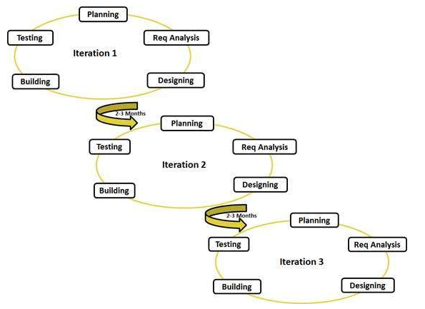

This figure displays the process involved in the Agile Model, as shown there are three iterations.

Advantages:
Some advantages when using the Agile model are:
- Resource requirements are minimum
- It is a good model for continuously changing software
- Easy to manage
- Gives flexibility to developers
- Functionality can be rapidly demonstrated

Disadvantages:
Some disadvantages associated with the agile model are:
- Depends heavily on customer interaction, if customer is unsure then team could head into the wrong direction
- Transfer of work can be difficult to new members due to lack of documentation
- More risk of sustainability and maintainability
- Not suitable for handling complex dependencies
http://www.tutorialspoint.com/sdlc/sdlc_agile_model.htm

Software Methodology Chosen:

The software methodology which has been chosen was the Waterfall model. This is because it has a much more defined approach compared to the agile model which is changing continuously. It would be the best approach to use the waterfall model because there is a clear picture of what the final product should be. Another reason is that agile is based on rapid production instead of quality of the product compared to the waterfall model which is based on definition compared to speed.
http://www.base36.com/2012/12/agile-waterfall-methodologies-a-side-by-side-comparison/

Design Approach

-Sequence Diagram

-Activity Diagram
-Class Diagram
Pseudocode
User Interface Design

- Implementation

Java

Java is one the most popular programming languages which was developed by Sun Microsystems which is now owned by Oracle. Java was developed long after languages such as C and C++. Because of this, Java incorporates many powerful features from these languages and also addresses their drawbacks. Java runs on various different platforms such as Windows, Mac OS and various versions of UNIX. This language also enforces Object Orientated programming model which is one of the reasons it was decided to be used for the development of this application. Being able to run on many different platforms is one of the strengths of Java, it does this by turn the Java compiler code into bytecodes instead of machine codes. When the program is executed it turns these bytecodes into machine code. Some basic concepts of Java are:

- Simple, object orientated and easy to learn
- It should be very performant

Android Studio

Android Studio is the official IDE for android development. Based on Jet Brains IntelliJ IDEA software. Android studio was specifically designed for Android Development. It also uses the Java programming language. Previously NetBeans was used as the primary Android development tool for Google, however it was overtaken by Android studio.

Text to Speech

Google Maps API

Project Scheduling (GitHub)

JSON Parsing

User Interface Representation

GPS

One of the features in this application was a GPS. The GPS displays to the user the current longitude and latitude of their location. After retrieving this information, it will use these co-ordinates and display the address of this location.
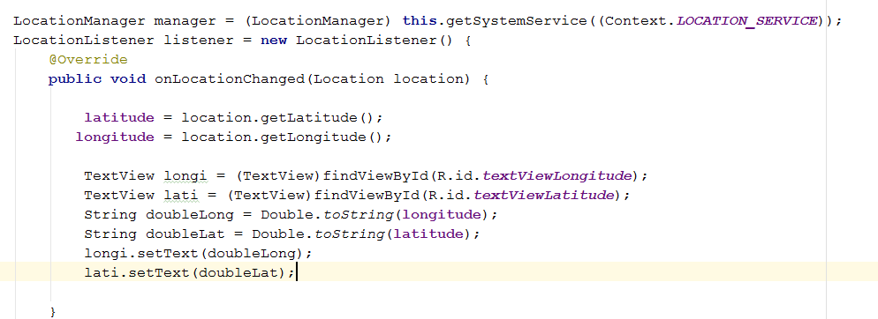

A location listener was needed to allow the application to listen in on the current location. However, in order to allow the application access to the internet and GPS that android phones have. They are both allowed permission in the AndroidManifest.xml file. This is done as shown on the screenshot below.

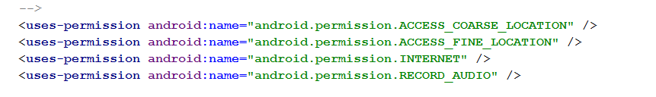

Every time the location is changed, this method retrieves both the latitude and longitude by using location.getLatitude() and location.getLongitude() which is then stored into variables with their respective names. These variables are Double and in order to display this on a Textfield. They would need to be converted into Strings. This is done by using the Double.toString() function.

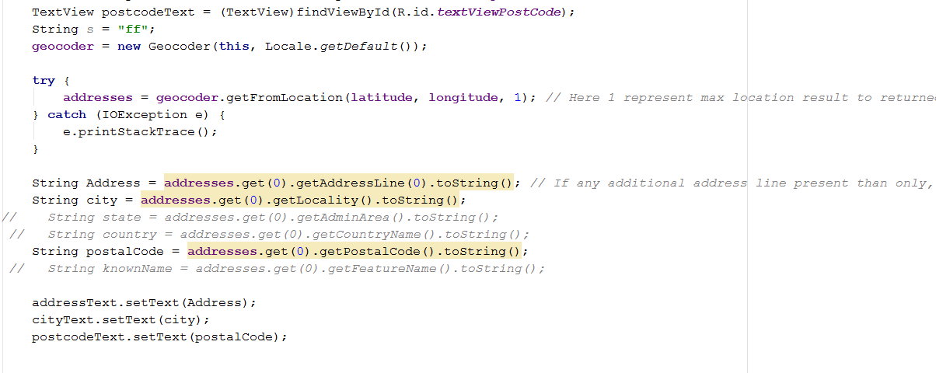
Figure:

To get the current address using the locations retrieved from the GPS, a geocoder was used. This uses the current longitude and latitude and can then be used to get the address which was then stored in a string and displayed.

Problems that occurred:

There were a few problems that occurred when using the GPS. One problem was when using the GPS, it would take between 10-15mins to receive the location. If there were many buildings around it would take a long time to retrieve the current location, this is because the application was using a GPS provider. This was fixed by using both a GPS provider and a NETWORK provider which allowed it to be more accurate and also a lot less time consuming. After using the network provider, the time it takes retrieving the co-ordinates was between 2-5 seconds.
Directions

One other feature which was included during the design stage and use case diagram was to have directions. With the directions, the user should be able to search an origin and destination and by selecting a transport type for example walking, cycling or driving. Directions will be displayed for that search and a map will be displayed showing a visual of the directions and also the system will display to the user, the text instructions.

An additional function which was added was to have alternative routes to be displayed, the user will then be able to select a particular route and be able to retrieve directions

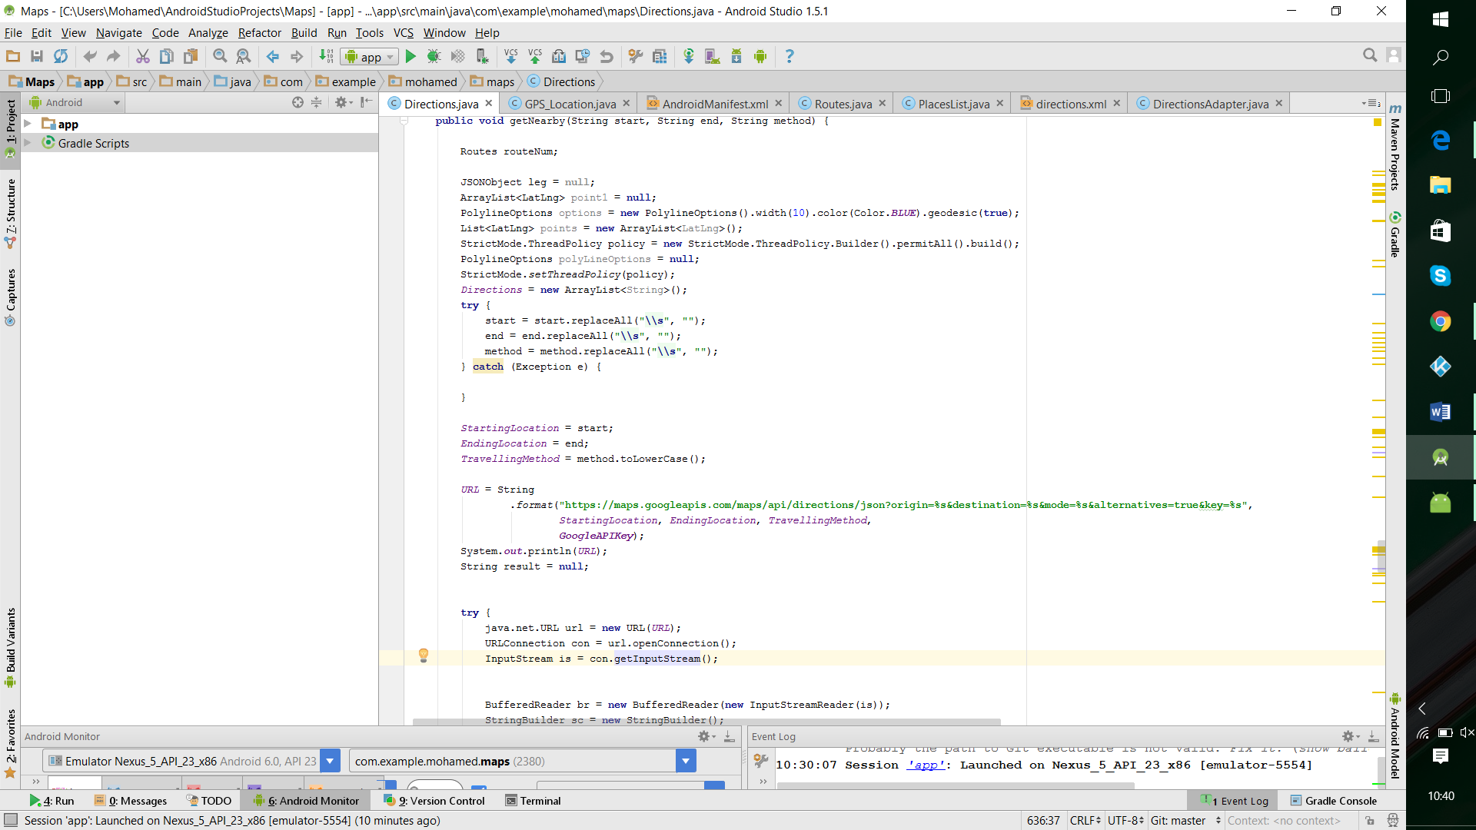
In order to receive directions, the Google Directions API was used. With the URL the start location and end location are needed along with the travelling method and Google API key. The URL used can be found at figure below.

Figure:

Within this URL it must also be stated whether to receive XML data or JSON data. In this case JSON data was chosen. In order to store different routes for each directions search, a Route

- Testing
Black box testing
White box testing
Test Cases

- Evaluation and Future Work
Future

